17.04. Importing prescribers
You need to be logged in to the store (dispensary) where the prescribers will prescribe before carrying out these steps.
Applicable in Dispensary mode only
From the File menu, choose Import Prescribers, and the Import alert window is displayed.
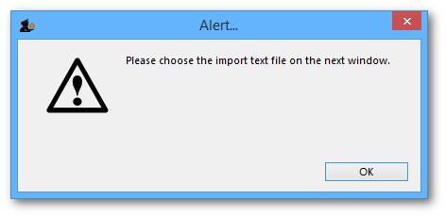
You may import a list of prescribers who have the authority to prescribe medicines.
Your list should be in the format of a 6-column spreadsheet, saved as a tab delimited file. The columns should be in the following order:
Column | Contents | Unique code for each prescriber
A | Code | Unique code for each prescriber
B | Last name | The presciber's last name
C | First name | The presciber's first name
D | Initials | The prescriber's initials. These will appear on patient labels
E | Registration code | The prescriber's registration code
F | Category | The category the presciber belongs to
Your tab delimited spreadsheet file would appear something like this:
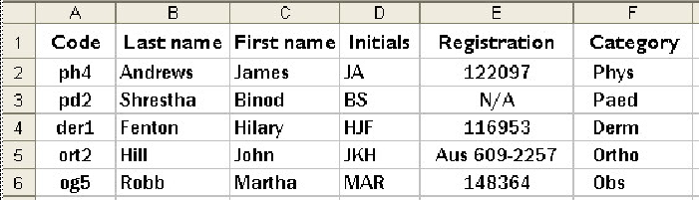
If the file you are importing has non-English characters (for example, accents), it is important to make sure the file is saved with a UTF-8 charset. You can check this by opening the file in Notepad (for Windows). When you save the file, you can choose the Charset used, as shown in the image below.

Choose import options from the preview window and click OK to begin import.
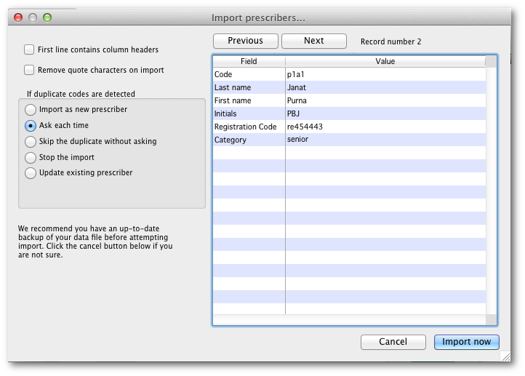
If there are non-printable characters before or after the first name, last name or code they will be removed. Any non-printable characters in the first name, last name or code will be replaced with an underscore (_).

Previous: 17.03. Importing names | | Next: 17.05. Importing abbreviations

